Mirror-A000-Asia-China-Mirror-W. Han 206 BCE-9 CE-four divine beasts, divinity and animal design, 7 Nipple

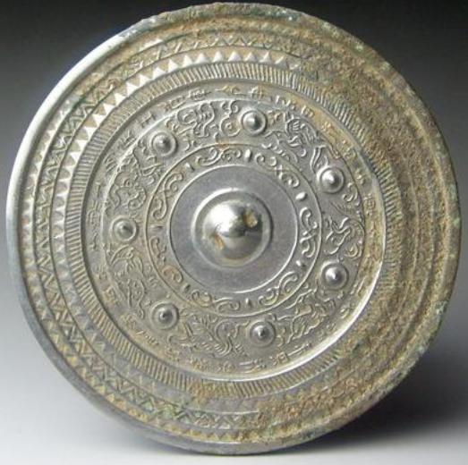

Rim, flat raised ban, three inner saw tooth bans the middle one being double saw tooth, inner section diagonally hachured , raised circle, seven nipples . Band with animals: phoenix, phoenix, dragon, Dragon Master (Huanlong Shi), black turtle, ram, tiger

The broad rim with its saw tooth bands suggests that this is related to other TLV mirrors of the Western Han dynasty. The inner band with seven nipples partition the divine animals and the Dragon Master (Huanlong Shi) who was reputed to have raised dragons for Emperor Xia.

